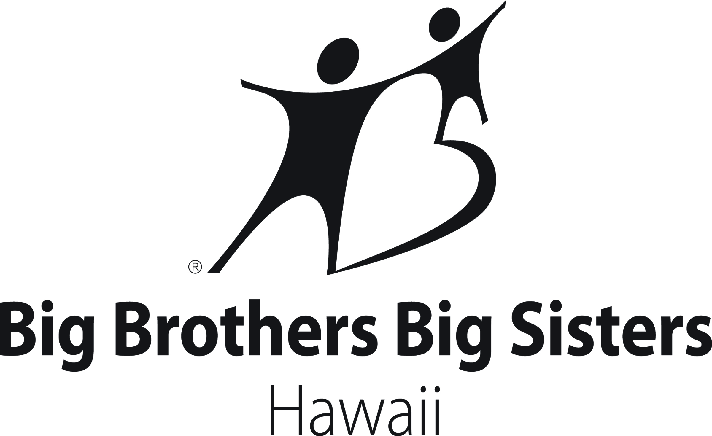
School-Based Youth Enrollment Form

Aloha Parents and Guardians,

Thank you for your interest in enrolling your child in the Big Brothers Big Sisters School-Based Mentoring Program! This program will utilize online communication as well as in-person outings/meetings to form strong, safe, positive and meaningful relationships between students and adult mentors, and promote college and career readiness through curriculum, activities and discussions.
Online and in-person meetings will be supported by Big Brothers Big Sisters, with the goal of providing students opportunities to grow into responsible, young adults. Our volunteer mentors are all individually interviewed, screened and provided with initial and ongoing training. We provide an environment where creativity, critical thinking, collaboration and adaptability are encouraged through online and in-person interactions. School mentoring reinforces the ABCs of “Attendance, Behavior and Course Performance” and exposes students to experiences and relationships with their mentor that promote an academic mindset and fosters resiliency in youth.
There is no cost to you or your child’s school to participate. We do, however, ask for consistent communication with parents and guardians and ongoing participation from students.
If you want your child to have this opportunity, please fill out this application in its entirety. This program is limited to 10 students, so please turn in your child’s application to the school contact listed below as soon as possible.
Castle High School Online communication Amanda Miyamoto
and in-person meetings (TBD) College & Career Resource Center
(808) 233-5600 x 2218

School Meeting Day/Time School Contact
Youth Information
_____________________________________________________________________________________
First name Middle name Last name

________________________________________________________________________________________________________
Date of Birth Age Grade School

________________________________________________________________________________________________________
Male/Female Ethnicity (Ex. Caucasian, Hawaiian, Asian, etc.)

________________________________________________________________________________________________________
Free/Reduced Lunch (Yes/No) Native Hawaiian Ancestry (Yes/No) Is your child a U.S. Citizen (Yes/No)

________________________________________________________________________________________________________
Would your child be a first-generation college student?

________________________________________________________________________________________________________
Cell phone Email Address

Parent/Guardian Information
_____________________________________________________________________________________
First name Last name

________________________________________________________________________________________________________
Relationship to Child (Ex. Mother, father, guardian, etc.)

_____________________________________________________________________________________
Mailing Address Apt. #

________________________________________________________________________________________________________
City State Zip Code

________________________________________________________________________________________________________
Home Phone Work Phone Cell Phone

________________________________________________________________________________________________________
Email

________________________________________________________________________________________________________
Who lives with the child (Ex. Mother, father, brother, sister, grandfather, grandmother, uncle, aunt, etc.)?

________________________________________________________________________________________________________
Incarcerated parent(s)? (Yes/No) Is one or are both of the current guardians enlisted in the military? (Yes/No)

Emergency Contact
_____________________________________________________________________________________
First Name Last Name Relationship to Youth

________________________________________________________________________________________________________
Home Phone Work Phone Cell Phone

Youth Medical Information
Please use this section to tell us any medical information about your child that we should aware about. This includes any medications, allergies, physical challenges or religious restrictions your child may have.

________________________________________________________________________________________________________

________________________________________________________________________________________________________

Parent Referral Information
Please use this section to tell us where you feel a mentor could help your child? For example, encourage a positive attitude towards school, promote constructive classroom behavior, support your child’s self-esteem, etc.
________________________________________________________________________________________________________

________________________________________________________________________________________________________

Please use this section to give us an idea of your child’s home environment and preferences. For example, does your child spend a lot of time reading or do they enjoy sports? Do they spend a lot of time with the neighbors or do they spend free time watching television? This will help us to have a better idea of what type of mentor to match your child with.
________________________________________________________________________________________________________

________________________________________________________________________________________________________

Please check boxes with words that you feel best describe your child:

€Active €Attentive €Aggressive €Competitive €Caring €Outgoing €Has a lot of friends €Keeps to himself/herself €Athletic €Book smart €Short attention span €Enjoys being around adults €Mature €Shy €Outgoing €Playful €Follows direction well €Challenges authority €Other __________________________________________________________

Additional comments:
________________________________________________________________________________________________________

________________________________________________________________________________________________________

Parent/Guardian Permission and Signature
I give permission:
- for my child to participate in the Big Brothers Big Sisters Hawaii Program;
- for the school to provide social and academic information about my child to Big Brothers Big Sisters Hawaii (e.g. attendance reports, behavior reports, etc.);
- to have my child complete a questionnaire containing questions about peer relationships, feelings about school, grades, educational expectations, parental relationships, and attitudes toward risky behaviors;
- to have my child talk with a Big Brothers Big Sisters Hawaii staff person about home life, personal interests, and personal safety

_____________________________________________________________________________________
Signature of parent/guardian Date
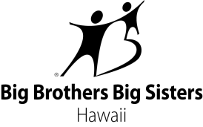
TALENT RELEASE FORM

A parent/guardian must fill out this form

I hereby accept the invitation of Big Brothers Big Sisters Hawaii (BBBSH) to appear and be identified in print in any BBBSH publication or production, or grant the right to use the image of the minor child as specified below.
I hereby grant to BBBSH, its affiliates and partners the right to use this image, name, and biographical information as they may desire, in all media and in all forms including, but not limited to, publications, any televised photography and recordings.
In consideration of $0 to me paid, I hereby grant to BBBSH and its affiliates the absolute right to use this image made through BBBSH studios or elsewhere, in whole or in part, in true or distorted character or form, alone or in conjunction with any other image, name or reproduction, in color or otherwise, for art, advertising, business, trade, or any other lawful purpose whatsoever, in perpetuum.
I hereby release BBBSH, its affiliates and partners from all claims, demands or liabilities and related financial costs that I may now or hereafter have arising in connection with BBBSH’s exercise of the right hereby granted, with my (or minor child’s) appearance in any publication or production. These include, without limitation, claims for compensation, defamation, or invasion of privacy, or other infringements or violations of personal or property rights of any sort whatsoever.

PARENT/GUARDIAN SIGNATURE: DATE: _____

PRINTED NAME: _____

CHILD’S NAME:_______________________________________________________________________

