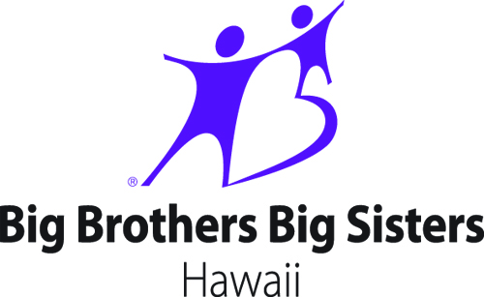
BOWLER PLEDGE SHEET

Bowler Name (Please Print): _______________________________________ Phone: __________________________
Address: ______________________________________________ Email: _____________________________________
Team Name/Company: _______________________________ Team Captain: _________________________________
Once completed: please send, or bring this form and monies raised to:
Big Brothers Big Sisters, attn: Kendra Chong
418 Kuwili St, Suite 106, Honolulu HI 96817

Donor’s Name (Please Print) | Mailing Address, City, State, Zip Code | Amount
 |  | $
 |  | $
 |  | $
 |  | $
 |  | $
 |  | $
 |  | $
 |  | $
 |  | $
 |  | $
 |  | $
 |  | $
 |  | $
 |  | $
 |  | $
 |  | $
 |  | $
 |  | $
 |  | $
 |  | $
 |  | $
 |  | $
 |  | $
 | TOTAL | $
2016 Bowl For Kids’ Sake -- Saturday, September 10th & Saturday, September 17th
Aiea Bowl, Aiea Shopping Center 3rd Floor, 99-120 Moanalua Road, Aiea, HI 96701

