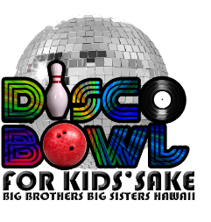
DISCO BOWL FOR KIDS’ SAKE 2016
DONATION FORM
DATE: ______________________
LAST NAME, FIRST NAME ____________________________________
ADDRESS: _________________________________________________________________________________
PHONE: ______________________________ EMAIL: ______________________________________________
DONATION DESIGNATION:
- Would you like your donation to counts towards a team or participant?
PARTICIPANT: ________________________________ TEAM NAME: __________________________________
- Would you like dedicate your donation to someone?
__________________________________________________________________________________________
Please mail, or bring this form along with the donation to:
Big Brothers Big Sisters Hawaii
Attn: Kendra Chong
418 Kuwili Street, Suite 106, Honolulu, HI 96817

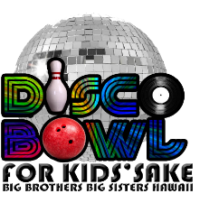
DISCO BOWL FOR KIDS’ SAKE 2016
DONATION FORM
DATE: ______________________
LAST NAME, FIRST NAME ____________________________________
ADDRESS: _________________________________________________________________________________
PHONE: ______________________________ EMAIL: ______________________________________________
DONATION DESIGNATION:
- Would you like your donation to counts towards a team or participant?
PARTICIPANT: ________________________________ TEAM NAME: __________________________________
- Would you like dedicate your donation to someone?
__________________________________________________________________________________________
Please mail, or bring this form along with the donation to:
Big Brothers Big Sisters Hawaii
Attn: Kendra Chong
418 Kuwili Street, Suite 106, Honolulu, HI 96817

